PRESS RELEASE
March 28, 2016
http://www.thestranger.com/slog

VISUAL ART

The New Rockland Residency in the Central District Is So Cool

by Jen Graves • Monday at 9:32 am
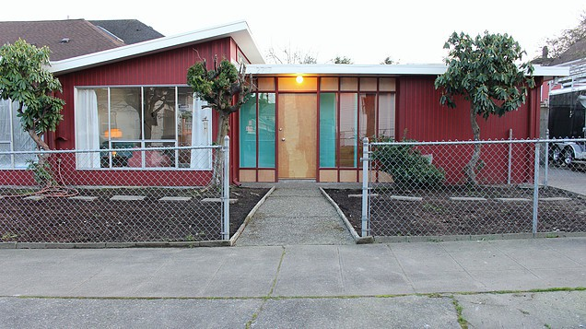
This is the house in the Central District where nine months of short-term rentals pays for three months of free artist residencies every year now, thanks to artists Shawn Landis and Jodi Rockwell. COURTESY OF SHAWN LANDIS AND JODI ROCKWELL
You know what, these artists are smart and there's nothing that smells like BS or needs unpacking in their press release—I particularly like that they want the artists to be part of the neighborhood—so I'm just going to let them tell you about the brand new Rockland Residency (emphases mine):
Rockland is a free residency program co-founded by [Seattle] visual artists Shawn Landis and Jodi Rockwell for dedicated writers, musicians, and artists of all genres who want to come to Seattle for inspiration and connection. The first residents are here February, March and April from Finland, Mexico, Argentina, Washington D.C. and Chicago. Rockland offers each of them a 2-4 week stay in the “Butterfly House,” a 1963 duplex designed by Victor Steinbrueck, the architect most famous for preserving Pike Place Market, Pioneer Square and design contribution for the Space Needle.
Rockland has no fee. Acceptance is based upon artistic merit and the proposed intention for the residency. In its first year, there were thirty-eight (38) competitive applicants from twelve (12) different countries, including South Korea, Australia, Netherlands, France, Germany, and Pakistan. The program is paid for by short-term rentals in the remaining nine months unoccupied by residents and long-term rental in the other half of the duplex. Rockland is proud (and relieved) to be a sustainable model without the need for fundraising.
“I developed the Rockland Residency concept to counter the trend in the Central District of monetizing every square block with very little investment in culture or community space. As a teenager, I learned the punk principle: Do what you can with what you got and hope the rest falls into place and space. To this end, it’s my family’s small and direct action to chisel out a place for creatives to occupy, artworking with immunity from the stresses of the capitalist system,” states Landis.
To acknowledge each resident during their time at Rockland, Landis requested they design a personal flag, most of which he sewed himself. The flag will be flown at Rockland, alerting the Central District of their occupation. Landis and Rockwell will host an evening meal for each resident, inviting local artists, other neighborhood residents and writers to connect through inspiring conversation. Rockland will rely on communal studios at local organizations and will recommend galleries, readings and performances throughout the city to meet the interests of each resident.
The first residents are Liz Flock, a journalist working on her first novel to be published by HarperCollins in 2017; cellist and videographer Katherine Trimble; Mexican visual artist Hilario Tovar, muralist Carla Bertone from Buenos Aires by way of Berlin; and Finnish artist Henriikka Kontimo.

